四川省普通高校职教师资和高职班对口招生统一考试
英 语 样 题
（2015年版）
本试卷分第Ⅰ卷（选择题）和第Ⅱ卷（非选择题）两部分。第I卷1至9页，第II卷10至11页。考生作答时，须将答案答在答题卡上。在本试卷、草稿纸上答题无效。满分100分。考试时间120分钟。考试结束后，将本试卷和答题卡一并交回。

第Ⅰ卷（共两部分 满分70分）

注意事项：
1. 选择题必须使用2B铅笔将答案标号填涂在答题卡上对应题目标号的位置上。
2. 第I卷共两部分，共70分。

第一部分 英语知识运用 （共两节；满分30分）
- 单项选择（共15小题；每小题1分，满分15分）
从A、B、C、D四个选项中，选出可以填入空白处的最佳选项，并在答题卡上将该项涂黑。
1. I earn 10 dollars _____ hour as ______ supermarket cashier on Saturdays.
A. a; an B. the; a C. an; a D. an; the
2. —Your coffee smells great!
— It’s from Mexico. Would you like _____?
A. it B. some C. this D. little
3. — Tom seldom tells lies, _______?
— No, you can trust him.
A. doesn’t he B. didn’t he C. does he D. will he
4. I am not sure _______ English is spoken in South Africa or not.
A. whether B. if C. that D. weather
5. — _______ is he?
— He is an engineer.
A. Whose B. What C. Who D. Whom
6. This is the room ______ I live.
A. in which B. which C. that D. in where
7. Paper _______ wood.
A. make from B. is made from C. is made of D. are made
8. — Do you mind my smoking here?
— _______!
- No, thanks B. No. Good idea C. Yes, please D. Yes. Better not
9. A number of students______ playing on the ground but I don’t know what the exact number ______.
A. is; are B. are; are C. is; is D. are; is
10. —Rose, will you go to the museum with me this afternoon?
—_____. My aunt is coming to see me.
A. Congratulations B. No problem. C. Sorry, I can’t D. Glad to hear that
11. The boy expressed his idea ______ means of drawing.
A. with B. by C. on D. in
12. His work _____ as very good by art experts.
A. regarded B. be regarded C. is regarded D. has regarded
13. — How about your weekend?
— Very boring. We could do nothing but ______ for the sky to clear up.
A. to be waiting B. to wait C. wait D. waiting
14. —We’ll have the exam next week; I’m really worried.
—______ .
A. Just so so B. Take it easy C. No need D. Too early
15. My house is ______ yours.
A. three times as big as B. as big three times as
C. big as three times as D. as three times big as

- 语言应用（共10小题；每小题1.5分，满分15分）
Part A 根据下列图片所提供的信息，从16~22题所给的三个选项（A、B、C）中，选出可以填入空白处的最佳选项，并在答题卡上将该项涂黑。
- When drivers see this sign, they need to ________.
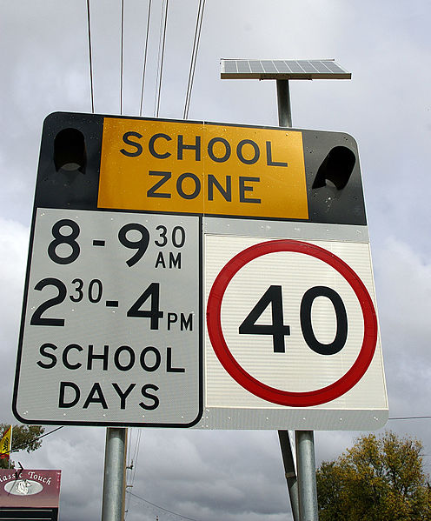
A. stop B. turn around C. drive slowly
- You go to ________ with this ticket.
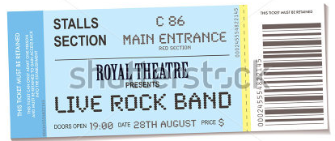
A. watch a concert B. see a movie C. visit a museum
- This sign means that you can buy things only ___________.

A. with a credit card B. with bank notes C. with a check
- The sign tells you that _________.

A. you can’t walk on the grass
B. you can’t touch the grass
C. you can’t pull out the grass
- The weather reporter will advise people to _______.
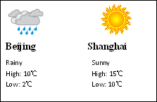
A. take an umbrella in Beijing
B. wash their cars in Beijing
C. have less outdoor activities in Shanghai
- The advertised 4G Kindle Fire is _______ dollars cheaper now.

A. 30 B. 100 C. 130
- Cindy will go to Nanjing on business with her boss. How much will she pay if they travel first class at 250kph?
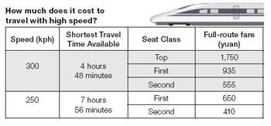
A. 1300 yuan. B. 1110 yuan. C. 1870 yuan.
Part B 根据下图提供的信息，从23~25题所给的三个选项（A、B、C）中，选出可以填入空白处的最佳选项，并在答题卡上将该项涂黑。
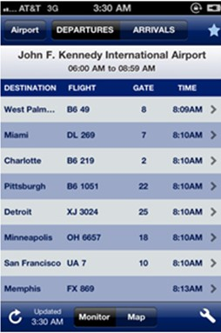
- What’s the gate number of the fight to San Francisco?
A. 10 B. 18 C. 25
- What’s the fight number to Detroit?
A. B6 219 B. XJ 3024 C. FX 869
- What time does the fight B6 1051 leave?
A. 8:09 AM B. 8:10AM C. 8:10 PM

第二部分 阅读理解（五篇短文，共20小题；每小题2分，满分40分）
阅读下列短文，从每题所给的四个选项（A、B、C、D）中，选出最佳选项，并在答题卡上将该项涂黑。
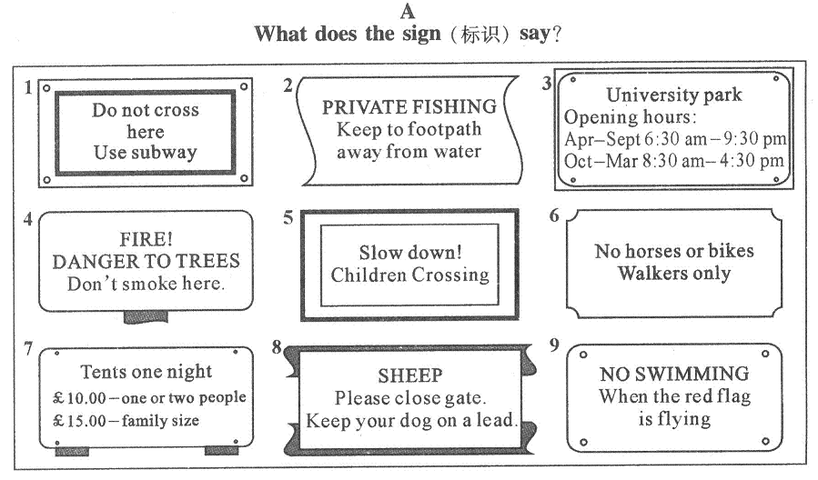
26. What time does the University Park open in March?
A. At 6:00 am. B. At 6:30 am. C. At 8:00 am. D. At 8:30 am.
27. Which sign tells you not to smoke?
A. Sign 2. B. Sign 4. C. Sign 6. D. Sign 8.
28. Where can you see Sign 9?
A. On the playground. B. At the school library.
C. Near the swimming pool. D. In the computer room.
B
The customs in different countries are rather different. If I have dinner with a Chinese host, he always puts more food onto my plate as soon as I have emptied it. That often discomforts(让……不舒服) me greatly. I have to eat the food even if I do not want to. I have also noticed that when a Chinese sits at an American’s dinner party, he very often refuses the offer of food or drink though he’s in fact still hungry or thirsty. This might be good manners in China, but it is not in the West at all. In the United States, it is impolite to keep asking someone again and again or insist on his accepting something. Americans have a direct way of speaking. If they want something, they will ask for it. If not, they will say, “No thanks.” When an American is served with beer by the host, for example, he might say, “No, thanks. I’ll take some orange juice if you have it. ” That is what an American will do. So when you go to the United States, you’d better remember the famous saying: “When in Rome, do as Romans do.”
29. From the passage we can see that the writer is ________.
A. a Chinese B. a Roman C. an American D. a Thailand
30. In the West, people consider it bad manners ________.
A. to put less food onto his plate B. to ask for something directly
C. to eat much at a dinner party D. to keep asking someone to accept something
31. A guest at an American’s dinner party should show his politeness by _________.
A. not eating up all the food offered
B. putting more food onto his plate as soon as he has emptied it
C. refuse the offer of food or drink though he is still hungry or thirsty
D. asking for things directly if he wants
32. “When in Rome, do as the Romans do” means ____________ .
A. the Romans are people of good manners
B. people in the United States want to learn from the Romans
C. Americans always do the same things as the Romans do
D. You should get used to the local customs wherever you go
C
Editor(编辑) Wanted
Editor needed to direct the work of new music magazine. At least two years editorial experience needed. Hours: 8:00 AM to 5:00 PM. Some overtime required. Send your personal information to : P.O. Box 213, Fairview, IN. 46243.
Bank Manager
Town Bank is looking for a bank manager to head its downtown branch(分行). A person with 5+ years experience. Working Hours: 8:30 AM to 5:30 PM. Mail to< newbank@gol.com >for more information.
Teachers Needed
Language Centre needs experienced teachers for its new English teaching program. PT/FT (兼/专职) positions available. No more than 25 teaching hours a week. AM/PM changes. Teachers with background in computer skills preferred(优先). Tel: 567 – 1243.
Nurses in Need
Child Care Centre serves children from 3 to 6 years of age. It provides care five days a week, and is open about ten hours a day. It is in great need of nurses with the experience of guiding(指导) different activities such as indoor and outdoor games. Call 432 – 3745 or visit our website: www.vps. Msu edu/efcr.
33. Person with of experience is needed to head the bank.
A. at least two years B. twenty – five years
C. three to six years D. more than five years
34. You should work for if you become an editor of the magazine.
A. just nine hours a day B. no less than nine hours a day
C. about ten hours a day D. less than 25 hours a week
35. If you want to be a teacher, you can for more information.
A. call 567 – 1243 B. mail to< newbank@gol.com>
C. phone 432 – 3745 D. write to P. O. Box 213, Fairview
36. You need to have the experience of directing different activities to .
A. be an editor of the music magazine B. head a bank branch of Town Bank
C. teach English in Language Centre D. work as a nurse in Child Care Centre
37. Which of the following is NOT true according to the passage?
A. Child Care Centre doesn’t provide care for children of all ages.
B. Teachers are wanted to teach English in the Language Centre.
C. One with computer skills will be preferred to head the bank.
D. Your own information is available for the position of the editor.
D
Man – made satellites have been sent up into space by many countries. These satellites go round the earth and help us to learn more about the earth, the weather and other things. Most countries use these satellites to send and receive messages. For example, with their help, China can send its TV and radio programmes to the other side of the world. Foreign countries can send their programmes to China. We can also use satellites to help to make telephone calls to foreign countries.
Our knowledge of the universe is growing all the time. Our knowledge grows and the universe becomes bigger, fuller or more completes. But thanks to space satellites, the world itself is becoming a much smaller space and people from different countries understand each other better.
38. With the help of satellites, the earth, the weather and other things can ________.
A. be learned very much B. be learned a lot
C. learn about more D. be learned more about
39. Satellites ________ send and receive messages.
A. are used B. have been used to
C. are used to D. have been used
40. Satellites can help us _______ our TV and radio programmes to ________.
A. to send, other people B. send, foreign countries
C. to send, another country D. send, a few countries
E
A young man was getting ready to finish school. For a long time he had looked forward to getting a beautiful sports car. He knew his father could well afford it, so he told him that was all he wanted.
Then on the morning of his graduation(毕业) , his father called him into his private study. His father told him how proud he was to have such a fine son, and told him how much he loved him. He handed his son a beautiful gift box. Surprised, the young man opened the box and found a lovely Bible(圣经) with his name on it. Angrily, he raised his voice to his father and said, “With all your money you give me a Bible?” He then rushed out of the house, leaving the Bible.
Many years passed and the young man was very successful in business. He had a beautiful home and a wonderful family, but realizing his father was very old, he thought perhaps he should go to see him. He had not seen him since that graduation day. Before he could make arrangements(安排), he received a phone telling him his father had passed away. He had to come home immediately and take care of the things that his father left him.
When he began to search through his father’s important papers, he saw the still new Bible, just as he had left it years ago. He opened the Bible and began to turn the pages. As he was reading , a car key with a tag(标牌) dropped from the back of the Bible. On the tag was the date of his graduation, and the words…”PAID IN FULL”. Sadness and regret filled his heart.
41. The underlined word “that” in Paragraph 1, means ________.
A. a car B. a box C. a Bible D. a phone
42. The young man was angry on the morning of his graduation because ________.
A. his father couldn’t afford a car B. he had to stay in his study
C. he thought he only got a Bible D. his father spent all the money
43. Which of the following isn’t mentioned in the third paragraph?
A. The young man succeeded in his business.
B. The young man lived with his father all the time.
C. The young man decided to see his father.
D. The young man set up his own family.
44. What’s the meaning of the underlined word “regret” in the last paragraph?
A. 遗憾 B. 后悔 C. 遗忘 D. 记得
45. It can be seen from the passage that the young man ________.
A. came to know the truth at last B. had to pay for the car himself
C. became interested in the Bible D. got angry with his father again

第Ⅱ卷（共三节 满分30分）

注意事项：
1. 必须使用0.5毫米黑色墨迹签字笔在答题卡上题目所指示的答题区域内作答。答在试题卷上无效。
2. 第II卷共三节，共计30分。

第一节 补全对话（共5小题；每小题1分，满分5分）
阅读下列对话，从所给选项中，选出能够完成对话的最佳选项，并将选项的字母代号写在答题卡相应的横线上。选项中有两个多余选项。
A: Excuse me, 46
B: I'll have a beer please.
A: Ok, here you are.
B: Thank you. 47
A: Well, all the drinks including beer are free of charge.
B: 48 Then I'd love more beer please.
A: Don't worry. I would be back again a little later.
(After a while.)
A: Are you finished?
B: Yes, may I have some more beer?
A: Oh, sure. 49
A: Thank you for waiting. Here it is. … Did you enjoy your meal?
B: Yes, the meal was very delicious and I enjoy it very much. I am full.
A: Is that so. 50

A. I'll be back in a minute.
B. Hold on, please.
C. How much is it?
D. Are you sure?
E. I am glad you enjoy it.
F. Thank you for your waiting.
G. would you like a drink before your meal?

第二节 翻译（共5 小题；每小题2分，满分10分）
Part A 请将下面的英语句子翻译成汉语，并将答案写在答题卡相应的横线上。
51. He studied so hard that he made great progress before long.
52. Whoever leaves the classroom last should turn off the lights.
53. Is this the factory some foreign guests visited yesterday?
Part B 请根据所给中文提示，将下列译成英语的句子补充完整，并把答案写在答题卡相应的横线上。
54. 邮局离这儿有些远，你最好坐车去。
The post office is ________________________ far from here._____________________ take a bus.
55. 毫无疑问，这本书值得一看。
There is ________________________ that this book is________________________.

第三节 书面表达（满分15分）
假设你是李华，毕业于东方旅游职业学校。你对报纸上登的这则招聘广告很感兴趣，请根据招聘广告的要求写一封求职信，介绍你的情况。
注意：1. 词数80词左右；2. 开头语及结尾已为你写好（不计入总词数）。

Guest Services Officer - Front Desk - Happy Hotel Chengdu
We are now inviting positive, self assured person with a really approachable manner for the position of Guest Services Officer at Happy Hotel Chengdu. Ideally, you'll have the following qualifications and experience we're looking for:
- Degree / Diploma Holder in Hospitality Management or related disciplines
- Relevant experience in luxury hotels / hospitality industry is a must
- Good proficiency in English, Putonghua and / or Japanese; additional language would be an advantage
- Pleasant, presentable, confident with outgoing personality
- Excellent customer service and interpersonal skills; proven team player
- Willing to work shift duties
In return, we’ll give you a generous financial and benefits package including healthcare support, pension scheme, hotel discounts worldwide and the chance to work with a great team of people. Most importantly, we’ll give you Room to be yourself.

To apply for this or any other jobs with our hotel, please contact us with our HR department at hr_cd@happyhotel.com for more information about this position.
注：以下内容在考试时应在答题卡上。
Dongfang Tourism Vocational School
No.15 Dongfang Road
Chengdu, 610000
6 June, 2011
Dear Sir,
I’ve learned from the newspaper that your hotel needs a guest services officer. I am writing to apply for this position.
____________________________________________________________________________________________________________________________________________________________…
If I’m given the job, I’ll try my best to do it well.
Thank you for your consideration. I’m looking forward to hearing from you.

Sincerely,
Li Hua
四川省普通高校职教师资和高职班对口招生统一考试
英语样题参考答案及评分标准
（2015年版）
第I卷
第一部分 英语知识运用 （共两节；满分30分）
第一节（共15小题；每小题1分，满分15分）
1~5: CBCAB 6~10: ABDDC 11~15: BCCBA
第二节（共10小题；每小题1.5分，满分15分）
16~20: CABAA 21~25: CAABB
第二部分 阅读理解（共20小题；每小题2分，满分40分）
26~30: DBCCD 31~35: DDDBA 36~40: DCDBB 41~45: ACBBA
第II卷
第一节 补全对话（共5小题；每小题1分，满分5分）
46~50: GCDAE
第二节 翻译（共5小题；每小题2分，满分10分）
51. 他学习如此努力，以至于不久就取得了巨大的进步。
52. 无论谁最后离开教室都应该关灯。
53. 这是昨天外国客人参观的那座工厂吗？
54. a bit; you’d better 55. no doubt; worth reading
评分意见：51～53小题，每小题2分。
翻译题评分意见：“英译汉”3个小题，“汉泽英”2个小题，每小题2分，满分10分。英译汉和汉译英的评分基本标准可归于达意和通顺两个方面。具体就是要求考生能正确理解和表达原文意义，译文全句结构正确、自然、通顺、流畅且符合汉语或英语表达习惯。各评分要点分布在关键词、词组、句型与语法结构的理解和翻译、译文的表达等三个方面。具体的评分细则如下：
1. 能正确理解和译出关键词、词组得0.5分。
2. 句型以及语法结构理解正确，表达自然得0.5分。
3. 译文结构正确、自然、通顺、符合汉语和英语的表达习惯得0.5分。
4. 如译文同时具备以上三点，既达意又通顺则可得2分。
第三节 书面表达（满分15分）
（一）评分原则
1. 总分为15分，按5个档次给分。
2. 评分时，先根据文章的内容的语言初步确定其所属档次，然后以该档次的要求来衡量，确定或调整档次，最后给分。
3. 词数少于60或多于100的，从总分中减去2分。
4. 评分时，应注意的主要内容为：内容要点、应用词汇和语法结构的数量和准确性、上下文的连贯性及语言的得体性。
5. 拼写与标点符号是语言准确性的一个方面，评分时，应视其对交际的影响程序予以考虑。英、美拼写及词汇用法均可接受。
6. 如果书写较差，以致影响交际，将分数降低一个档次。
（二）各档次的给分范围和要求
1. 第五档（很好）（13～15分）
完全完成了试题规定的任务。
——覆盖所有的内容要点。
——应用了较多的语法结构和词汇。
——语法结构或词汇方面有些许错误，但为尽力使用较复杂结构或词汇所致；具备较强的语言运用能力。
——有效地使用了语句间的连接成分，使全文结构紧凑。
——完全达到了预期的写作目的。
2. 第四档（好）（10～12分）
完全完成了试题规定的任务。
——虽漏掉了1个次重点，但履盖所有主要内容。
——应用的语法结构和词汇能满足任务的要求。
——语法结构或词汇方面应用基本准确，少许错误主要是因尝试较复杂语法结构或词汇所致。
——应用简单的语句间的连接成分，使全文结构紧凑。
达到了预期的写作目的。
3. 第三档（适当）（7～9分）
基本完成了试题规定的任务。
——漏掉一些内容，主要内容不够完整。
——应用的语法结构和词汇基本能满足任务的要求。
——有一些语法结构或词汇方面的错误，但不影响理解。
——应用简单的语句间的连接成分，使全文内容连贯。
整体而言，基本达到了预期的写作目的。
4. 第二档（较差）（4～6分）
未恰当完成试题规定的任务。
——漏掉或未描述清楚一些主要内容，写了一些无关内容。
——语法结构单调、词汇项目有限。
——有一些语法结构或词汇方面的错误，影响了对写作内容的理解。
——较少使用语句间的连接成分，内容缺少连贯性。
信息未能清楚地传达给读者。
5. 第一档（差）（1～3分）
未完成试题规定的任务。
——明显遗漏主要内容，写了一些无关内容，原因可能是未理解试题要求。
——语法结构单调、词汇项目有限。
——较多语法结构或词汇方面的错误，影响对写作内容的理解。
——缺乏语句间的连接成分，内容不连贯。
信息未能传达给读者。
0分
未能传达给读者任何信息：内容太少，无法评判；写的内容均与所要求内容无关或所写内容无法看清。
（三）说明
1. 内容要点可用不同方式表达。
2. 对紧扣主题的适当发挥不予扣分。
（四）范文
Dongfang Tourism Vocational School
No.15 Dongfang Road
Chengdu, 610000
6 June, 2011
Dear Sir,
I’ve learned from the newspaper that your hotel needs a guest services officer. I am writing to apply for this position.
My name is Li Hua. I graduated from Dongfang Tourism Vocational School and my major was Hospitality Management. I can speak Chinese and English fluently. During the last year in my studying, I worked in Holiday Inn in Chengdu as a receptionist trainee in the front office. The experience working in the five-star hotel makes me have confidence to handle the problems in customer service. I think I am qualified with your requirements.
If I’m given the job, I’ll try my best to do it well.
Thank you for your consideration. I’m looking forward to hearing from you.

Sincerely,
Li Hua

